A question of Welsh Athletics?

Week 1
Q1) How many events are there in track and field?
Q2) When did the modern Olympics begin?
1896 1900 1904
Q3) How many Welsh athletes have won medals?
10 13 15
Q4) Which Welsh male has one gold at the Olympics and what year and in which event?
Q5) What was the winning result?

Answers
Q1) 44
Q2) 1896 (6th April to be precise)
Q3) 13
(Male individual: 1 gold, 2 silver, 1 bronze
Male relays: 3 gold, 3 silver, 1 bronze
Female relays: 2 bronze)
Q4) Lynn Davies, Tokyo Olympics 1964, Long Jump
Q5) 8.07m

Week 2
Q1) Which Welsh Athlete took part in the 2016 Rio Olympics?
Q2) What was Colin Jackson’s 1988 Olympic final race time?
Q3) How many Olympic Games did Christian Malcolm compete in?
Q4) David Jacobs was the first Welsh athlete to win an Olympic gold medal as part of Britain’s 4 x 100m team. Where was this Olympics held and in what year?
Q5) What Olympics games was the first Welsh woman to win an Olympic medal in?
Q6) What was her name and her event?

Answers
Q1) Seren Bundy Davies (No Welsh male athletes - the first time since 1936)
Q2) 13.28
Q3) 4 (2000, 2004, 2008, 2012)
Q4) Stockholm 1912
Q5) Moscow 1980 (a bronze medal)
Q6) Michelle Probert, 4x400m

Week 3
Q1) When did the World Championships begin?
1965 1975 1985
Q2) How many Welsh athletes have been selected?
10 17 19
Q3) How many World Championship appearances did Colin Jackson make?
5 6 7
Q4) How many medals have been won by Welsh athletes?
8 10 12
Q5) What was the long standing world record time set by Colin Jackson and which World Championships did he set the world record at?
Q6) Hayley Tullett is the only female to win an individual medal which event and colour medal?

Answers
Q1) 1983 outdoors
Q2) 17 athletes indoors
Q3) 5 outdoors, 6 indoors
Q4) 12 medals indoors (Wales has an impressive medal haul with 2 gold medals, 5 silver medals and 5 bronze medals).
Q5) 12.91, Stuttgart 1993 (Colin held the record until Xiang Liu of China equalled it in 2004).
Q6) 1500m, bronze medal

Week 4
Q1) When did the Indoor World Championships begin?
1965 1975 1985
Q2) How many World Championship appearances did Christian Malcolm make?
5 6 7
Q3) Dai Greene won the 400m hurdles world championship title. What was his winning time, which location and year was this World Championship held?
Q4) When did the World Youth /U18 Championships begin?
1995 1999 2003
Q5) Who won a gold medal at the first event?
Q6) More recently which athlete won a Bronze medal for the 4x400 in 2019?

Answers
Q1) 1985
Q2) 5
Q3) 48.26, Daegu, 2011
Q4) 1999
Q5) Tim Benjamin
Q6) Joe Brier

Week 5
Q1) Who was the 1st female to medal in the European Indoor Championships 2015 to win an individual medal?
Q2) Who was the second female to win an individual bronze medal in 2019?
Q3) The European U23 Cup was held in 1992 and 1994. However this was discontinued to be replaced by full championships starting in 1997.
Which four Welsh athletes won individual gold medals?
Q4) What is Charlotte Arter's half marathon Welsh record time? ​
Q5) Who holds the 50k Welsh male Road walking record and what is the record time?
Q6) Which female athlete holds all of the Track and Road walking Welsh records?
Answers
Q1) Seren Bundy Davies won Wales' first individual bronze medal in 2015.
Q2) Melissa Courtney in 3000m.
Q3) In the 400m Hurdles - Matt Elias, Rhys Williams and Dai Greene and David Omoregie (110mH).
Q4) 69:41
Q4) Bob Dobson, his 50k Welsh Road walking record time 4:11:59
Q5) Bethan Davies

Week 6
Q1) What is Carys Parry’s Welsh record distance for Hammer?
Q2) Which British triathlete holds Welsh records for U17 1500m & 3000m, U20 1 mile & 3000m?
Q3) What is Julie Crane's Welsh record for High Jump?
Q4) What is Christian Malcolm's Welsh record for 100m?
Q5) What is Iwan Thomas’ Welsh record for 400m?
Q6) Colin Jackson holds the U20 Welsh record for Long Jump, what was his record distance?
Q7) Which Welsh athlete holds the Welsh record in Hammer with a distance of 71.62m?

Answers
Q1) 66.80m
Q2) Non Stanford
Q3) 1.89m
Q4) 10.11
Q5) 44.36
Q6) 7.56m
Q7) Osian Jones

Week 7
Q1) Where has Hannah Brier ran the Welsh 100m record?
Q2) How many women hold the Welsh 100m record and can you name them?
Q3) Which female ran the all comers 1500m record time 4:04:39 at Cwmbran in 1984?
Q4) Which male holds the 1983 Welsh record for 10,000m?

Answers
Q1) Columbia and Poland
Q2) Sallyanne Short, Elaine O'Neill and Hannah Brier.
Q3) Zola Budd
Q4) Steve Jones in time of 27:39.14 on the track

Week 8
Q1) What is Sally Peake’s pole vault Welsh record?
Q2) Who holds the discus Welsh records from under 20 to senior?
Q3) Which male high jumper, jumped the all comers record of 2.28m at Cardiff in 2010?
Q4) What is Ben Gregory’s decathlon Welsh record?

Answers
Q1) 4.40m
Q2) Brett Morse
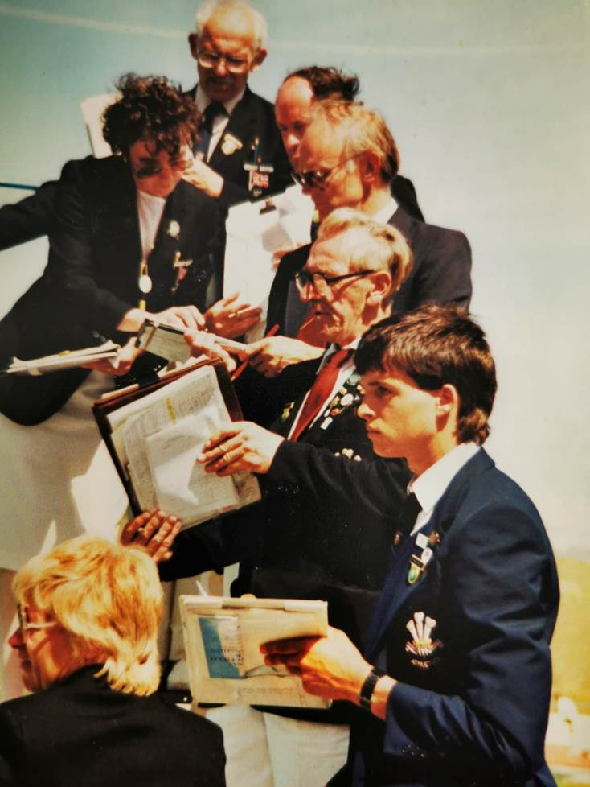
Q3) Robbie Grabarz
Q4) 7882

Officiating Flashback
Q1) Can you name the Track Judges?
Q2) Guess the year?
Q3) Guess the meeting?
Q4) Guess the venue?

Answers
Q2) 1987
Q3) Welsh Games
Q4) Swansea Morfa Stadium

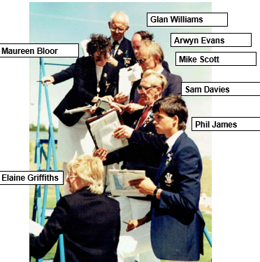

Officiating Flashback 2
Q1) Can you name the Track Judges with Lynn Davies?
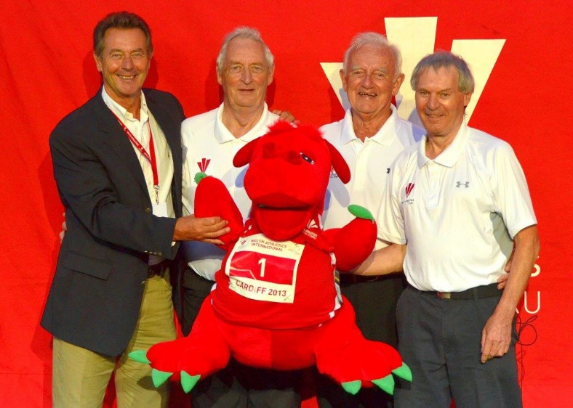
Q2) Guess the year?
Q3) Guess the meeting?
Q4) Guess the venue?

Answers
Q1) Richie Jenkins, John Tanner, Alan Currie (from left to right).
Q2) 2013
Q3) WA Senior Champs
Q4) Cardiff

Guess the club vest - week 1
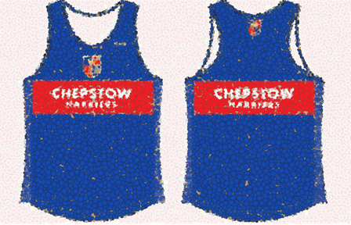
a)

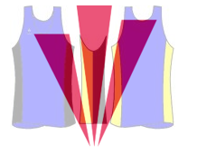
b)

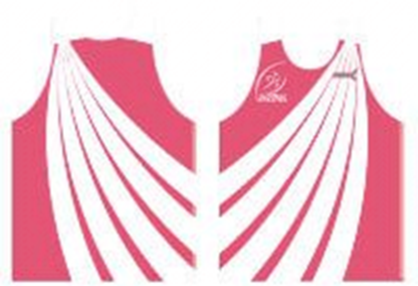
c)

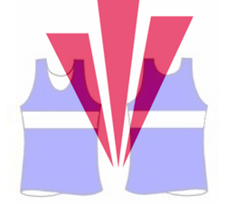
d)

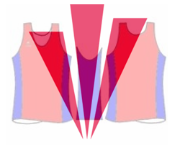
e)

